1. Test Plan Identifier
File Name: 1.0_AMAZON_tplan_v1.0.doc
Location: Hyderabad
2. Document History
REV | Author | Edits | Date
1.0 | Divya, Team leader, Project manager. | Initial Draft | 19/11/2024

3.Introduction
Amazon is a global technology and e-commerce giant founded by Jeff Bezos in 1994, initially as an online bookstore. It has since expanded into diverse domains, including online retail, cloud computing (via Amazon Web Services), digital streaming (Prime Video), and consumer electronics (e.g., Kindle and Alexa-enabled devices). Known for its customer-centric approach, Amazon offers a vast product range, personalized shopping experiences, and services like Amazon Prime for fast shipping and exclusive content. With a strong focus on innovation, automation, and sustainability, Amazon is a leader in shaping modern retail and cloud infrastructure while maintaining a significant global presence.

4. Features to be Tested
Medium priority features are features that have been stable and High Priority features are features that have been recently changed.

Feature To be Tested | Priority | Comments
Create Account | High
Mobile number | High
Editing Profile details
Search bar
Reviews and Ratings
Wish listing
Payment methods

- Features NOT to be Tested
Help Contents and user manage will not be tested.
Installation and presentation will not be tested.
Support of the other architectures also will not be tested.

- Test Strategy

The test strategy for AMAZON1.0 will include manual testing with automated testing where time/need permits. Automated testing will be used to test the basic Interface objects, keyboard and mouse navigation or any redundant tasks best translated to automation. Automated testing will be limited to a Win-64 platform because of Automation tool limitations.
- Sanity test will include an very short battery of tests to ensure the AMAZON1.0 runs/launches and can connect to the back end database. Test execution will happen as individual component testing. These tests will be fully automated.
- Acceptance tests will include a short battery of tests that will only touch major features to ensure AMAZON1.0 will operate smoothly at a basic level. These tests will be executed on Windows 98, Windows NT 4, Windows 2000, workstations and servers. The goal will be to automate all of these tests.
- Full Functional tests will include a comprehensive test of all features listed in this document. These tests will be limited to the Windows 2000 workstation client. These test will include automation with time allowing.
Functionality Testing

Registration
Verify New Registration
Verify details.
Login details
Search details
Product details
Order details
Review Details

Usability Testing
The usability testing will be accomplished by verifying the information in each window are accurate. Menus, icons and toolbar functionality will be tested as applicable to the navigation and results panes. Multi Window Overlapping will be tested because product supports opening of multiple documents.
Robustness/Reliability Testing
Test the GUI for correct keyboard and mouse navigation, windows, menus, buttons, etc. These tests will include Keyboard only navigation AMAZON1.0, Mouse only navigation. Correctness and existence of warning/error dialog boxes. The correct/expected functionality of buttons, icons and menus.

Stress Testing
Not applicable

7. Test Deliverables
Test plan 1.0_AMAZON_tplan.doc
Test Specification 1.0_AMAZON_tspec.doc
Test Automation Plan TBD
Test Checklist TBD
Test Logs TBD

8. Testing Tasks & Resource Needs
Use of MS Excel.
Write Test Specification.
Write Test Automation plan.
Write Test Checklist.
Setup workspace.
Develop Automation script using selenium.
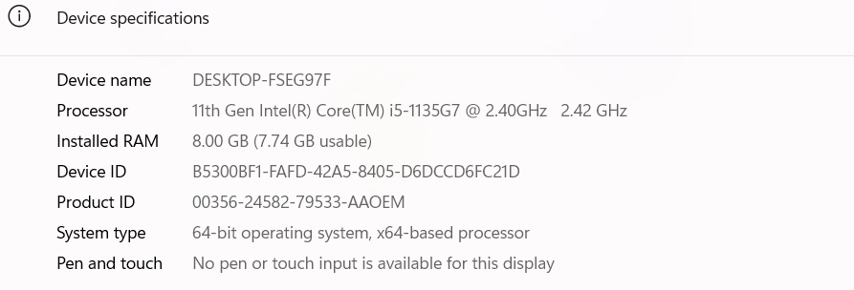

Minimum requirements for platforms:
Intel: Intel ~400mz, with 96mb* of Ram for NT workstation client.
Intel ~400mz, with 64mb *of Ram for 98 workstation client.
(* Automation needs an additional 128MBs to function)

9.Schedule
Test Documentation
Document | Development Time |  | Sign-off Date | Dependencies
 | Person-Days | Completion Date
Test Plan | 1day | 20/11/2024 |  | Functional Spec. Review
Test Specifications | 1 day | 20/11/2024 |  | Testplan, Functional Spec, Review
Test Logs | TBD
Test Summary Report | TBD
Checklist | TBD

Test Development
Deliverable | Development Time |  | Dependencies
 | Person-Days | Completion Date
Functional Test Suite | 1 | 20/11/2024
Automation build

Test Execution
Test Activity |  | Execution Time (Person-Days) |  |  | Dependencies
 |  | Alpha | Beta | FCS
Acceptance |  | 1Day | 1 Day | 1Day
Functional | Functionality | 1 | 1
 | Usability | All High to Medium testcaces
 | Robustness | All High to Medium testcaces
 | Stress | All High to Medium testcaces
 | Multi Inst. | All High to Medium testcaces
Regression
Documentation Review |  | 1? | 1? | 1?
Total Test Cycle |  | 1 | 1 | 1

10.Risks and Assumptions
Risks:
Environment Instability: Delays in setting up the test environment could impact the schedule- VM is not working port no.-5103
Resource Availability: Limited availability of testers could delay test execution.
Late Requirement Changes: Changes in requirements during the testing phase could lead to additional testing efforts.
Contingencies:
Backup Resources: Have backup resources ready to join the testing effort if required.
Flexible Schedule: Allocate buffer time in the schedule to accommodate unexpected delays.
Regular Communication: Hold daily stand-up meetings to quickly address any issues that arise

11.Approvals/Signoff

POSITION  *Approval required | NAME | SIGNATURE | REVIEWED | APPROVAL
Tech Lead | Divya |  | Divya | Divya
Project Manager | Raghavendra BN |  | Raghavendra BN | Raghavendra BN
Client Approval | WS Audiology |  | WS Audiology | WS Audiology

